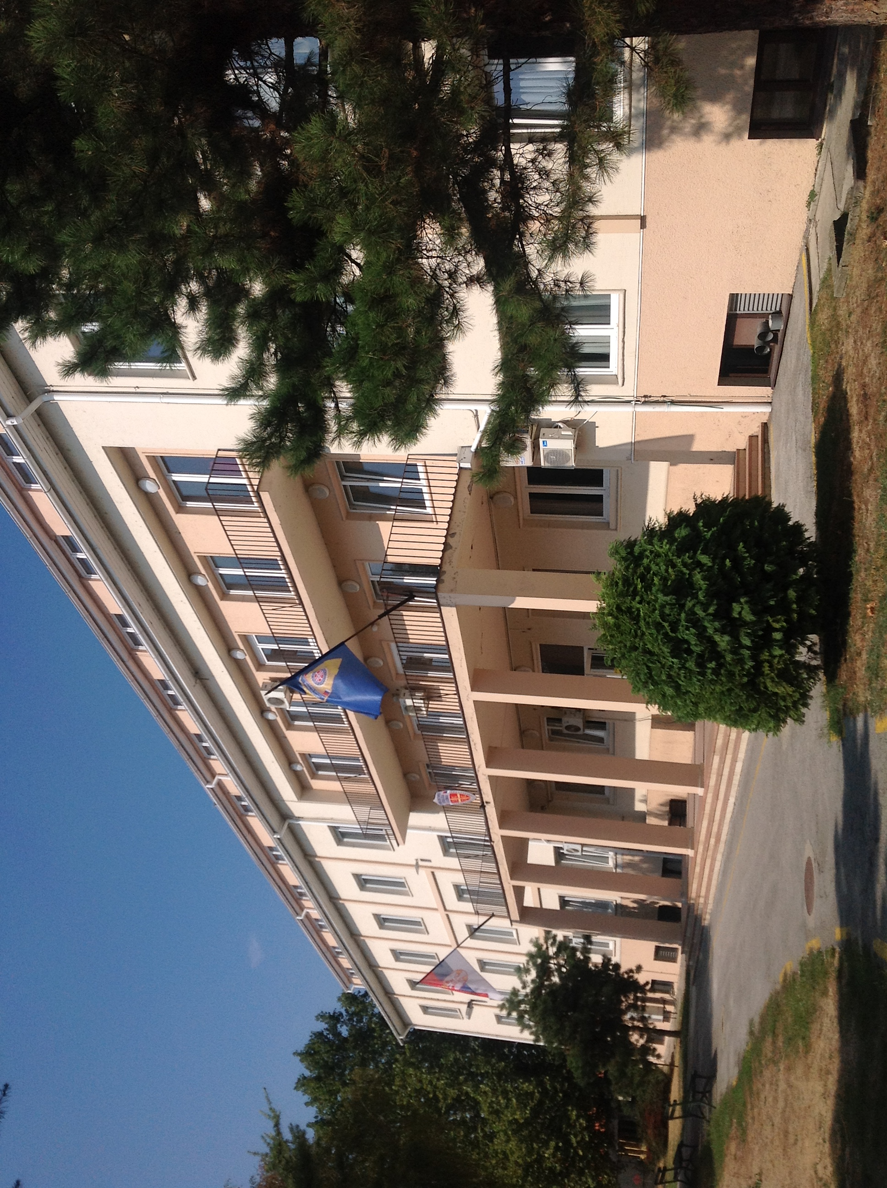

Guidelines for authors

Lenght of paper: one author's sheet (from 25.000 to 30.000 characters)

Language: English

Tekst format: MS Word 2007 and older (*.docx; *.doc)

Font: Times New Roman

Page format: A4 (210×297 mm)

Line spacing: Single

Margins: left 2.0 cm, right 1.5 cm, top 2.0 cm, bottom 1.5 cm

Title of the paper: 12 pt., bold, alignment centred, capital letters

Name/s of the author/s: 11 pt., alignment centred, the author that will present the paper should be underlined

Institutions and E-mail addresses: 11 pt., italic, alignment centred

Abstract and key words: 11 pt., alignment justified

Text: 11 pt., alignment justified, titles of chapters should be written using capital letters, without numeration

References: 11 pt., enumerated in alphabetical order

Picture title: 11 pt., italic, centred below picture
Table title: 11 pt., italic, centred above table

References in the text: 9 pt., footnotes

Pictures: eligible formats: TIF, GIF, JPG, BMP, WMF and CDR

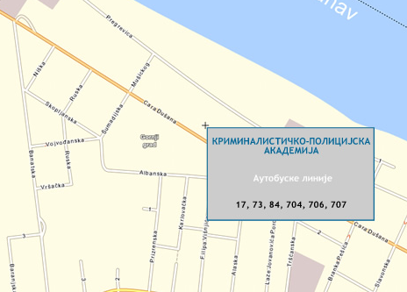

ACADEMY OF CRIMINALISTIC AND POLICE STUDIES, BELGRADE



CALL FOR PAPERS FOR INTERNATIONAL SCIENTIFIC CONFERENCE

ARCHIBALD REISS DAYS

TOPIC: RULE OF LAW, POLICE AND CRIME SUPPRESSION

1-2 March 2013

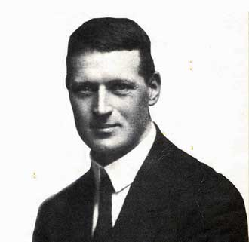

The International Scientific Conference „Archibald Reiss Days“ will be organized by the Academy of Criminalistic and Police Studies in Belgrade, in co-operation with the Ministry of Interior and the Ministry of Education, Science and Technological Development of the Republic of Serbia, China Criminal Police University, Lviv State University of Internal Affairs, Volgograd Academy of the Russian Internal Affairs Ministry, Faculty of Security in Skopje, Faculty of Criminal Justice and Security in Ljubljana, Police Academy „Alexandru Ioan Cuza“ in Bucharest, Academy of Police Force in Bratislava and Police College in Banjaluka.

Conference topics:
- Management in State Administration
- Current Problems in Structuring and Functioning
of a Police Organization
- Crime and Penal and Legal Response
- Forensic Methods in Criminalistic Identifications
- Contemporary Concepts in Criminalistics
- Contemporary Security Studies and Security of the Republic of Serbia

The organiser invites all scientific and professional institutions to take part at the Conference by presenting the latest results of their scientific research projects, as well as other related activities.

Working language of the Conference is English.

The Conference will be organised in plenary and thematic sessions. Plenary lectures will be given by invitation.

Papers presented at the Conference will be published in the Conference Proceedings.

The authors of accepted papers and representatives of co-organizers will not pay the participation fee. Other participants pay participation fee of 10.000 RSD.

Papers should be submitted to E-mail address arcibald13@kpa.edu.rs

Information on the Conference: www.kpa.edu.rs
E-mail: arcibald13@kpa.edu.rs
Contact: Vuk Kulić: +381 11 3107225
Dušan Blagojević: +381 11 3107173

Deadlines:
Abstract submission and registration 15 December 2012
Notice of acceptance of abstract 25 December 2012
Paper submission 30 January 2013
Notice of acceptance of paper 20 February 2013

PROGRAMME COMMITTEE
Goran Milošević, PhD, Dean of the ACPS, President
Wang Shiquan, PhD, President of the China Criminal Police University
Mychaylo Cymbaluk, PhD, Rector of the Lviv State University of Internal Affairs, Ukraine
Ivan Toth, PhD, Dean of the University of Applied Sciences in Velika Gorica, Croatia
Gheorghe Popa, PhD, Rector of the Police Academy "Alexandru Ioan Cuza", Romania
Vladimir V. Gordienko, PhD, Head of the Academy of Management of the Interior Ministry of Russia
Vladimir Tretyakov, PhD, Chief of the Volgograd Academy of the Russian Internal Affairs Ministry
Hasan Hüseyin Çevik, PhD, Deputy Rector of the Turkish National Police Academy
Piotr Bogdalski, PhD, Commandant-Rector of the Police Academy in Szczytno, Poland
Helene Martini, PhD, Director of the France’s National Police College and President of the Association of European Police Colleges
Ladislav Šimák, PhD, Dean of the Faculty of Special Engineering, University of Zilina, Slovakia
Peter Ruzsonyi, PhD, Dean of the Faculty of Law Enforcement, Hungary
Snežana Nikodinovska-Stefanovska, PhD, Dean of the Faculty of Security, Macedonia
Sonja Tomović Šundić, PhD, Dean of the Faculty of Political Sciences in Podgorica, Montenegro
Jozef Metenko, PhD, Academy of Police Force, Slovakia
Vid Jakulin, PhD, Faculty of Law, University of Ljubljana, Slovenia
Darko Maver, PhD, Faculty of Criminal Justice and Security, University of Maribor,Slovenia
Nedžad Korajlić, PhD, Director of the Institute of Criminalistics, Forensic Research and Court Expertise, University of Sarajevo, Bosnia and Herzegovina
Mile Šikman, PhD, MoI of the Republic of Srpska
Miroslav Vesković, PhD, Rector of the University of Novi Sad
Sima Avramović, PhD, Dean of the Faculty of Law in Belgrade
Radomir Milašinović, PhD, Dean of the Faculty of Security in Belgrade
Major-General Mladen Vuruna, PhD, Head of the Military Academy
Slobodan Nedeljković, Assistant to the Minister, Serbian MoI
Miloš Oparnica, Assistant to the Minister, MoI of the Republic of Serbia
Police General Branislav Mitrović, Deputy Police Director,Serbian MoI
ORGANIZING COMMITTEE
Željko Nikač, PhD, Vice Dean of the ACPS, President
Milorad Todorović, Secretary of the MoI of the Republic of Serbia
Lazar Nešić, National Criminalistic-Technical Centre, Serbian MoI
Goran Amidžić, MA, Police College, Republic of Srpska
Đorđe Đorđević, PhD, ACPS
Ljiljana Mašković, PhD, ACPS
Milan Žarković, PhD, ACPS
Goran Boškovič, PhD, ACPS
Dane Subošić, PhD, ACPS
Mladen Bajagić, PhD, ACPS
SECRETARIAT
Vuk Kulić
Renata Samardžić, MA
Tehnička podrška
Marta Tomić, MA, Marija Blagojević, MA, Dušan Blagojević, Jelena Pandža

REGISTRATION FORM

Name, Surname and Title:

Title of the paper:

Topic of the paper:

Institution:
Address:

E-mail:

Telephone :

Mark with X one of the following options:
Participation with paper | Participation without paper

Signature:

______________________________

Date:

______________________________

