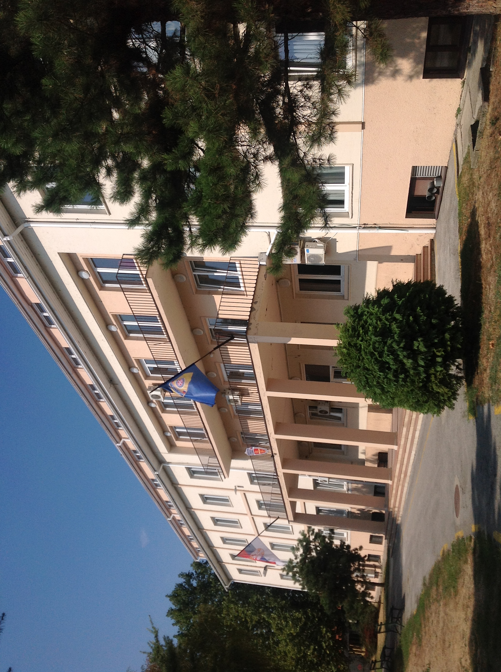

Guidelines for authors

Lenght of paper: one author's sheet (from 25.000 to 30.000 characters)

Language: English

Tekst format: MS Word 2007 and older (*.docx; *.doc)

Font: Times New Roman

Page format: A4 (210×297 mm)

Line spacing: Single

Margins: left 2.0 cm, right 1.5 cm, top 2.0 cm, bottom 1.5 cm

Title of the paper: 12 pt., bold, alignment centred, capital letters

Name/s of the author/s: 11 pt., alignment centred, the author that will present the paper should be underlined

Institutions and E-mail addresses: 11 pt., italic, alignment centred

Abstract and key words: 11 pt., alignment justified

Text: 11 pt., alignment justified, titles of chapters should be written using capital letters, without numeration

References: 11 pt., enumerated in alphabetical order

Picture title: 11 pt., italic, centred below picture
Table title: 11 pt., italic, centred above table

References in the text: 9 pt., footnotes

Pictures: eligible formats: TIF, GIF, JPG, BMP, WMF and CDR

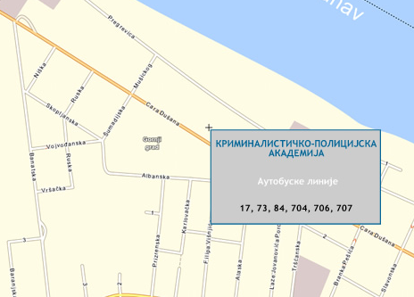

ACADEMY OF CRIMINALISTIC
AND POLICE STUDIES, BELGRADE





FIRST NOTICE AND CALL FOR PAPERS FOR

INTERNATIONAL SCIENTIFIC CONFERENCE

ARCHIBALD REISS DAYS

3-4 March 2014

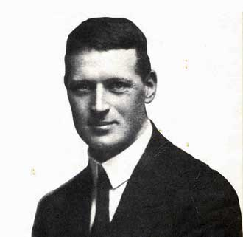

The International Scientific Conference „Archibald Reiss Days“ will be organized by the Academy of Criminalistic and Police Studies in Belgrade, in co-operation with IRZ Foundation from Bon, the Ministry of Interior of the Republic of Serbia and the Ministry of Education, Science and Technological Development of the Republic of Serbia, China Criminal Police University, Lviv State University of Internal Affairs, Volgograd Academy of the Russian Internal Affairs Ministry, Faculty of Security in Skopje, Faculty of Criminal Justice and Security in Ljubljana, Police Academy „Alexandru Ioan Cuza“ in Bucharest, Academy of Police Force in Bratislava and Police College in Banjaluka.

Conference topics:
- Innovation and Standardization of Criminalistic
and Forensic Methods
- Human Resource Management in Police
- Security in Emergency Situations
- Strengthening the State's Institutions
and Fight Against Crime
- Social, Economic and Political Flows of Crime
- Manifestation, Measuring and Analysis
- Forensic Linguistic

The organiser invites all scientific and professional institutions to take part at the Conference by presenting the latest results of their scientific research projects, as well as other related activities.

Working language of the Conference are English, Russian and Serbian.

The Conference will be organised in plenary and thematic sessions. Plenary lectures will be given by invitation.

Papers presented at the Conference will be published in the Conference Proceedings.

The authors of accepted papers and representatives of co-organizers will not pay the participation fee. Other participants pay participation fee of 10.000 RSD.

Papers should be submitted to E-mail address arcibald14@kpa.edu.rs

Information on the Conference: www.kpa.edu.rs
E-mail: arcibald14@kpa.edu.rs
Contact: Vuk Kulić: +381 11 3107226
Ivana Stevanović: +381 11 3107170

Deadlines:
Abstract submission and registration 01 December 2013
Notice of acceptance of abstract 10 December 2013
Paper submission 10 January 2014
Notice of acceptance of paper 01 February 2014
PROGRAMME COMMITTEE
Goran Milošević, PhD, Dean of the ACPS, President
Dr. Stefan Pürner, Head of Section South-East Europe Middle, IRZ
Wang Shiquan, PhD, President of the China Criminal Police University
Mychaylo Cymbaluk, PhD, Rector of the Lviv State University of Internal Affairs, Ukraine
Ivan Toth, PhD, Dean of the University of Applied Sciences Velika Gorica, Croatia
Gheorghe Popa, PhD, Rector of the Police Academy "Alexandru Ioan Cuza", Bucharest, Romania
Vladimir Gordienko, PhD, Head of the Academy of Management of the Interior Ministry of Russia
Vladimir Tretyakov, PhD, Chief of the Volgograd Academy of the Russian Internal Affairs Ministry
Hasan Hüseyin Çevik, PhD, Deputy Rector of the Turkish National Police Academy
Piotr Bogdalski, PhD, Commandant-Rector of the Police Academy in Szczytno, Poland
Hélène Martini, PhD, Director of the France’s National Police College and President of the Association of European Police Colleges
Ladislav Šimák, PhD, Dean of the Faculty of Special Engineering, University of Zilina, Slovakia
Peter Ruzsonyi, PhD, Dean of the Faculty of Law Enforcement, Hungary
Oliver Bačanović, PhD, Dean of the Faculty of Security, Skopje, Macedonia
Dragan Radonjić, PhD, Dean of the Faculty of Law, Podgorica, Montenegro
Štefan Kočan, PhD, Academy of Police Force, Bratislava, Slovakia
Peter Grilc, PhD, Faculty of Law, University of Ljubljana, Slovenia
Gorazd Meško, PhD, Faculty of Criminal Justice and Security, University of Maribor, Slovenia
Nedžad Korajlić, PhD, Dean of the Faculty for Criminal Justice, Criminology and Security Studies, University of Sarajevo, Bosnia and Herzegovina
Mile Šikman, PhD, MoI of the Republic of Srpska
Tanja Tripović, Acting Dean of Police academy in Danilovgrad
Miroslav Vesković, PhD, Rector of the University of Novi Sad
Sima Avramović, PhD, Dean of the Faculty of Law in Belgrade
Zoran Stojanović, PhD, full professor Faculty of Law in Belgrade
Radomir Milašinović, PhD, Dean of the Faculty of Security in Belgrade
Major-General Mladen Vuruna, PhD, Head of the Military Academy
Slobodan Nedeljković, Assistant to the Minister, Serbian MoI
Miloš Oparnica, Assistant to the Minister, MoI of the Republic of Serbia
Police General Branislav Mitrović, Deputy Police Director, Serbian MoI

ORGANIZING COMMITTEE
Dragana Kolarić, PhD, Vice Dean of the ACPS, President
Milorad Todorović, Secretary of the MoI of the Republic of Serbia
Lazar Nešić, National Criminalistic-Technical Centre, Serbian MoI
Goran Amidžić, PhD, Police College, Republic of Srpska
Srđan Milašinović, PhD, Vice Dean of the ACPS
Biljana Simeunović-Patić, PhD, Vice Dean of the ACPS
Ljiljana Mašković, PhD, ACPS
Đorđe Đorđević, PhD, ACPS
Milan Žarković, PhD, ACPS
Mladen Bajagić, PhD, ACPS
Dane Subošić, PhD, ACPS
Nikola Milašinović, PhD, ACPS

SECRETARIAT
Renata Samardžić, MA, Jelena Pandža, Ivana Stevanović, Vuk Kulić
ž
TECHNICAL SUPPORT
Marta Tomić, MA, spec. Dušan Blagojević

REGISTRATION FORM

Name, Surname and Title:

Title of the paper:

Topic of the paper:

Institution:
Address:

E-mail:

Telephone :

Mark with X one of the following options:
Participation with paper | Participation without paper

Signature:

______________________________

Date:

______________________________

